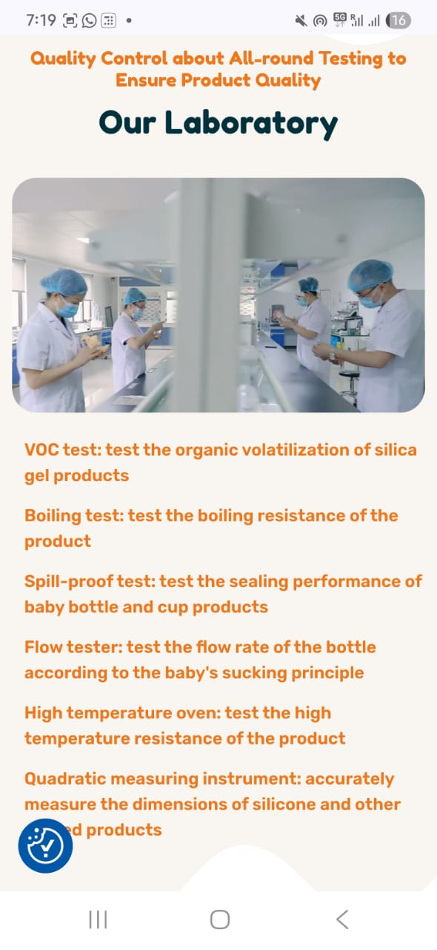

**1. Material Testing**

* **BPA Test / Bisphenol A Content Test** – Ensure BPA-free materials (mandatory).
* **Heavy Metal Content Test** – Detect toxic elements (Lead, Cadmium, Arsenic, etc.).
* **Food Grade Certification** – Compliance with IS 14625 / ISO 10993 / FDA 21 CFR.
* **FTIR / DSC Analysis** – Confirm polymer identity and thermal properties.

**🔹 2. Physical & Functional Tests**

* **Leakage Test** – Ensure no leaks from bottle, nipple, or valve.
* **Drop Test** – Assess breakage when dropped from standard heights.
* **Pull/Teat Retention Test** – Nipple must not detach when pulled with force (safety test).
* **Teat Flow Rate Test** – Measure liquid flow based on nipple type (slow, medium, fast).
* **Teat Hole Size Consistency** – Ensures proper feeding and no choking hazard.
* **Ventilation/Anti-Colic System Test** – Test if air venting is working correctly.

**🔹 3. Chemical Resistance & Stability Tests**

* **Sterilization Compatibility** – Check durability under:
  + Boiling
  + Steam sterilizer
  + Microwave sterilizer
  + UV sterilization
* **Dishwasher Compatibility** – Test resistance to heat and detergent.
* **Migration Tests (Specific & Overall)** – As per BIS/EN 14350/FDA (migration of chemicals into food simulants).

**🔹 4. Dimensional & Visual Checks**

* **Wall Thickness Uniformity**
* **Weight Consistency**
* **Volume Calibration Test** – Ensure printed measurements are accurate.
* **Visual Inspection** – Bubbles, black specs, short shot, flash, weld lines, etc.

**🔹 5. Printing Quality Tests**

* **Adhesion Test (Tape Test)** – Ensure logo/markings don't peel off.
* **Print Durability Test** – After multiple washes/sterilization cycles.

**🔹 6. Packaging Quality Checks**

* **Seal Strength Test**
* **Tamper Evidence Test**
* **Labeling Check** – Ensure batch number, MRP, manufacturing date, BPA-free mark, ISI mark (if applicable).

**All our products are in compliance with**

* **IS 14625** (BIS Standard for plastic feeding bottles)
* **EN 14350** (European standard)
* **ASTM (American standard)**
* **FDA 21 CFR** (U.S. standard)
* **ISO 9001 / ISO 13485** (for quality systems and medical devices)